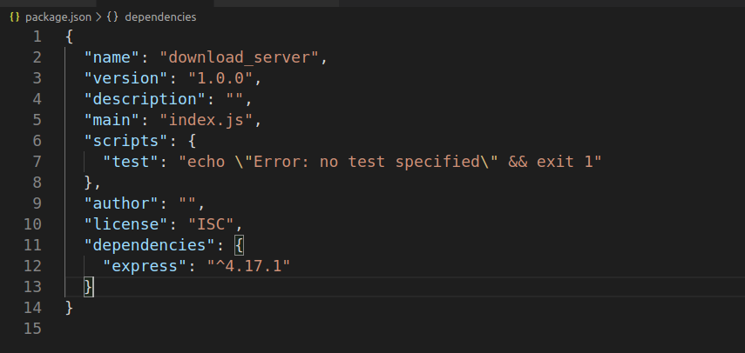1342453465623545234523453245234523453245234523454352345234523452345324523452435234545345!!@#$%^&*(((((((((((*&^%$#@!@#$%^&*(*&^%$#@#$%^&*&^%$#@!#$%^&******(((()(*&^%$#@!@#$%^&*()_+_)(*&^%$#@!!!!!!!!!!@#$%^&*()____